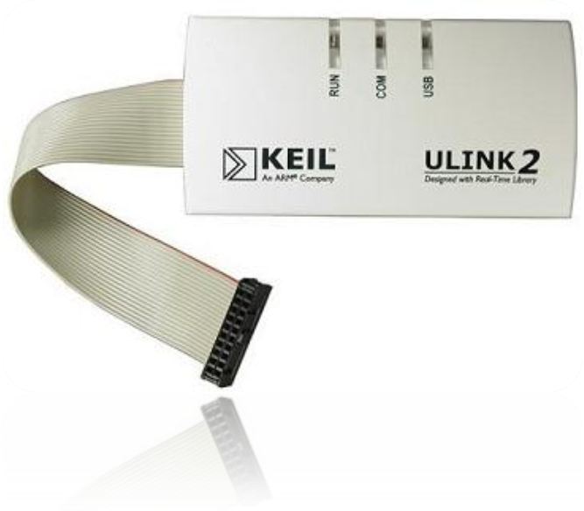



The Keil ULINK2 USB- JTAG Adapter connects your PC's USB port to your target system (via JTAG, SWD, or OCDS) and allows you to program and debug embedded programs on target hardware.
ULINK2 Features:

- Plug-and-Play installation using standard Windows USB drivers
- Serial Wire Debug (SWD) support for ARM Cortex-M3 based devices
- Real-Time Trace for Cortex-M3 using Serial Wire Viewer (SWV)
- NXP 2-wire debug interface (P89LPC952 and P89LPC954) support
- Real-Time Agent with memory R/W during execution, terminal emulation, and serial debug output
- 10-pin and 20-pin connector support

ULINK2 may be used for:

- On-chip Debugging (using on-chip JTAG, SWD, or SWV),
- Flash Memory Programming (using user-configurable Flash programming

